**Implementing CRM for Result tracking of a candidate with internal marks**

**1**. **Introduction**

Are you new to Salesforce? Not sure exactly what it is, or how to use it? Don’t know where you should start on your learning journey? If you’ve answered yes to any of these questions, then you’re in the right place. This module is for you.

Welcome to Salesforce! Salesforce is game-changing technology, with a host of productivity-boosting features, that will help you sell smarter and faster. As you work toward your badge for this module, we’ll take you through these features and answer the question, “What is Salesforce, anyway?”

**1.1 Overview**

Administrator should be able to create all base data including Semester, Candidate, Course and Lecturer ,Lecturer should have the ability to create Internal Results, Dean, who is one of the Lecturer, should be the only one with ability to update Inter ,Re-evaluation Can be initialised by Candidate for all Internal Results .Now only dean can update the marks after re- evaluation

**1.2 Purpose**

Sales professionals use customer relationship management (CRM) software to keep track of their prospects and clients. It [organizes client information](https://project-management.com/crm-for-enterprise/), sends reminders and automated emails, facilitates team communication, tracks performance, and generates reports among other things.

What not a lot of project managers know, though, is that [CRMs are very versatile](https://project-management.com/what-is-customer-relationship-management-crm/). The platform’s powerful features can help you stay on top of your projects, teams, and stakeholders, so you can achieve project success. Here are the ways CRM software can help you in project management.

To develop a successful CRM strategy, you need a clear vision that your team can collaborate on and execute. It requires your ability to discern between good and poor leads so that you can prioritize your actions. Implementing a CRM strategy is an ongoing effort. You may want to continue to keep track of your leads, carry out targeted marketing campaigns and revaluate your actions.

**2 Problem Definition & Design Thinking**

*Problem definition*

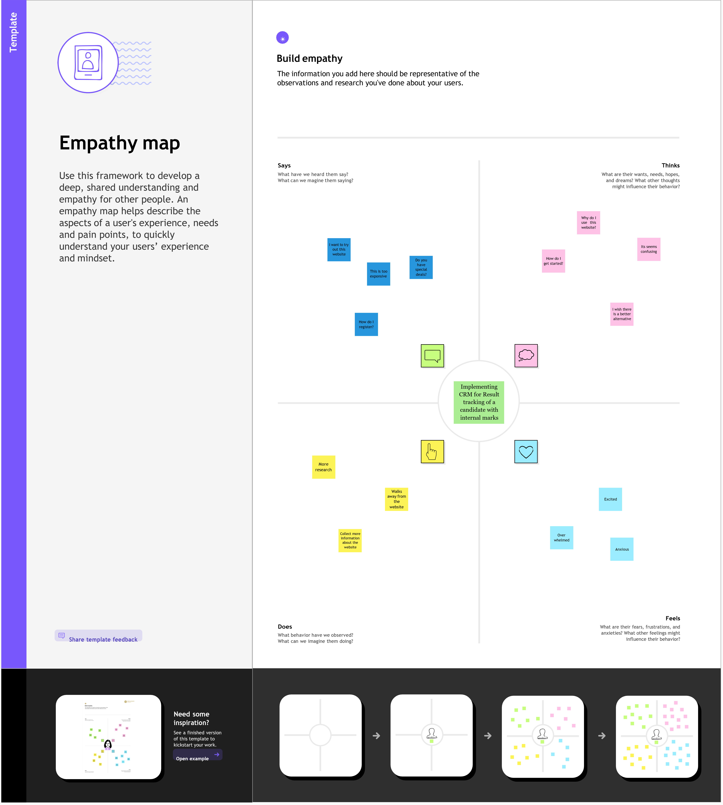Process improvement projects are used by many businesses and organizations to make improvements in the way they operate. Several things are important to a successful process improvement project, but every project begins with identifying the problem that needs to be resolved. Understanding what a problem statement is and how to write one can help you become more successful when working on process improvement projects.

*Design Thinking*

Design thinking is an evolutionary (iterative), human-design and problem solving method that applies deep empathy for users and collaboration among a broad team. Instead of designers working alone, they team with other stakeholders which makes the process symbiotic with agile methods

**2.1 Empathy MAP**

**Empathy map Use this framework to develop a deep, shared understanding and empathy for other people. An empathy map helps describe the aspects of a user's experience, needs and pain points, to quickly understand your users’ experience and mind**

**2.1 Empathy Map**

****An empathy map is a collaborative tool teams can use to gain a deeper insight into their customers. Much like a user persona,

**2.2 Ideation and Brainstorming Map**

**Ideation**

**Ideation is often the most exciting stage in a Design Thinking project, because during Ideation, the aim is to generate a large quantity of ideas that the team can then filter and cut down into the best, most practical or most innovative ones in order to inspire new and better design solutions and products.**

**Brainstorming Map**

**Concept mapping is a brainstorming technique that lets you visualize concepts and ideas. Also known as “mind mapping”, this technique starts with a research question or main idea, then adds branches with synonyms, related topic, keywords, and examples.**

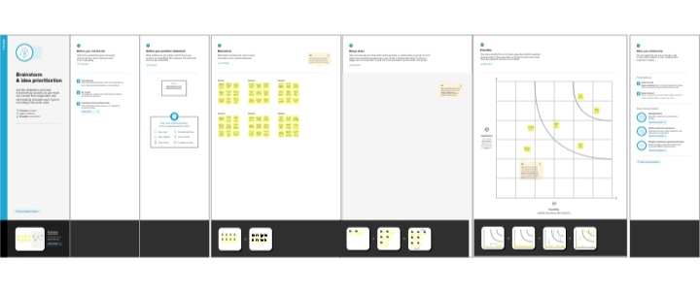

**This is for brainstorming in CRM screen short . about that the brainstorming make to the broject in the brainstorming.**

**3 Result**

**CRM can improve customer retention by 27%, and companies that use CRM systems to the full extent can increase sales by 29%, based on Salesforce studies. Moreover, the right CRM implementation helps sales reps shorten their sales cycles by up to 14%**

**3.1 Data Model:**

|  |  |  |  |
| --- | --- | --- | --- |
| **Object name** | | **Fields in the object** | |
| 1.Semester | | |  |  | | --- | --- | | Field Label | Data Type | | Semester | Text | | |
| 2.Candidate | | |  |  | | --- | --- | | Field Lapel | Data Type | | Candidate | Text | | |
| 3.CourseDetails | | |  |  | | --- | --- | | Field Label | Data Type | | Course Details | Text | | |
| 4.LectureDetails | | |  |  | | --- | --- | | Filed Label | Data Type | | Lecture Details | Text | | |
| 5.Internal results | | |  |  | | --- | --- | | Filed Label | Data Type | | Internal results | Text | | |
|  | |

**3.2 Activity**

**Milestone :1**

**Salesforce**

Introduction

Are you new to Salesforce? Not sure exactly what it is, or how to use it? Don’t know where you should start on your learning journey? If you’ve answered yes to any of these questions, then you’re in the right place. This module is for you.  
  
Welcome to Salesforce! Salesforce is game-changing technology, with a host of productivity-boosting features, that will help you sell smarter and faster

Salesforce has everything you need to run your business from anywhere. Using standard products and features, you can manage relationships with prospects and customers, collaborate and engage with employees and partners, and store your data securely in the cloud.

So what does that really mean? Well, before Salesforce, your contacts, emails, follow-up tasks, and prospective deals might have been organized something like this: <https://youtu.be/r9EX3lGde5k>

**Activity:1**

**Creating Developer Account**

**Creating a developer org in salesforce.**

Creating a developer org in salesforce.

1. Go to [https://developer.salesforce.com](https://developer.salesforce.com/)

2. Click on sign up.

3. On the sign up form, enter the following details :

a. First name & Last name

a. Email

b. Role : Developer

c. Company : College Name

d. County : India

e. Postal Code : pin code

f. Username : should be a combination of your name and company

This need not be an actual email id, you can give anything in the format : username@organization.com

Click on sign up after filling these.

Account Activation

Go to the inbox of the email that you used while signing up. Click on the verify account to

activate your account. The email may take 5-10mins, as

Login To Your Salesforce Account

1.Go to salesforce.com and click on login.

2.Enter the username and password that you just created.

3.After login this is the home page which you will see.

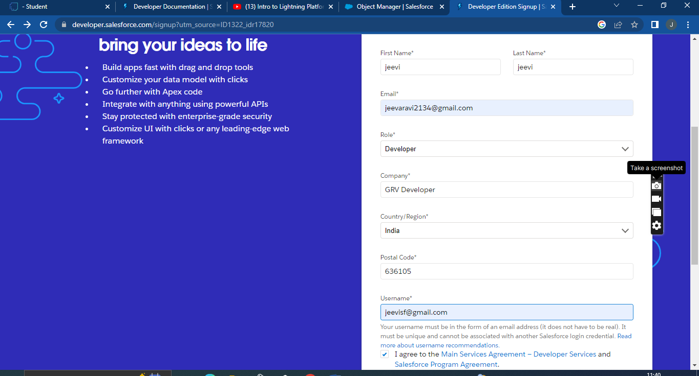

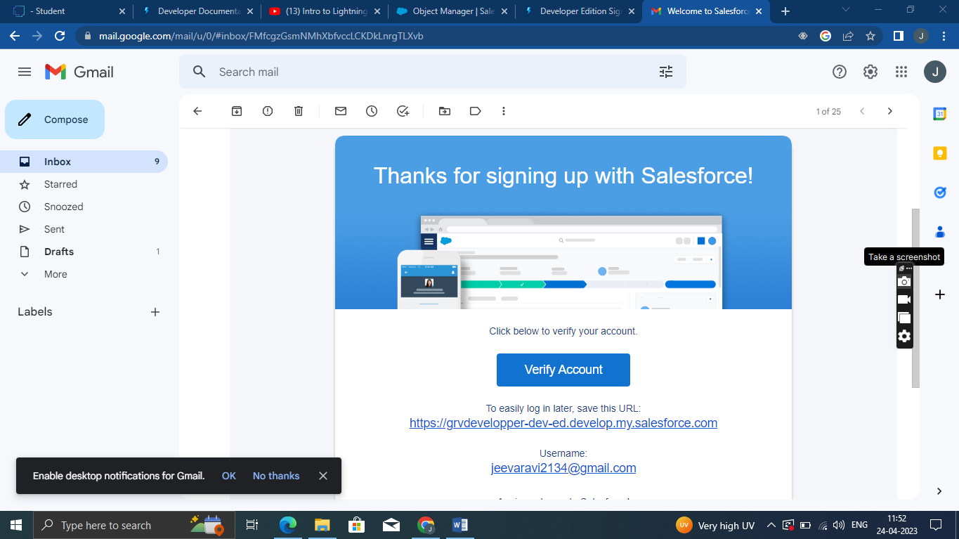

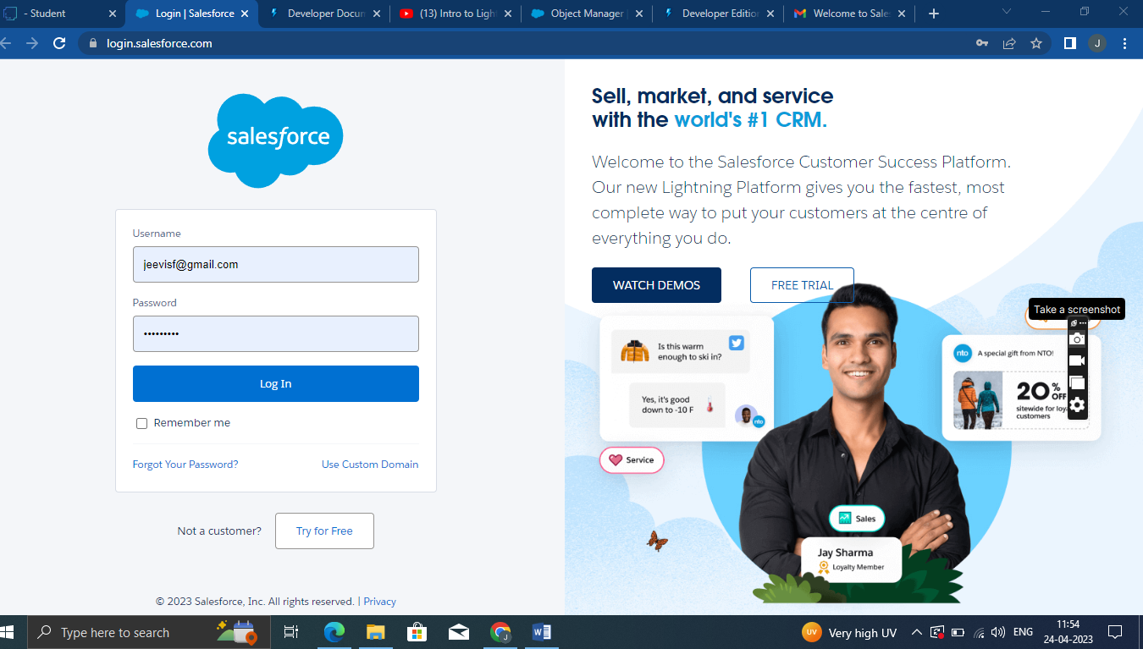

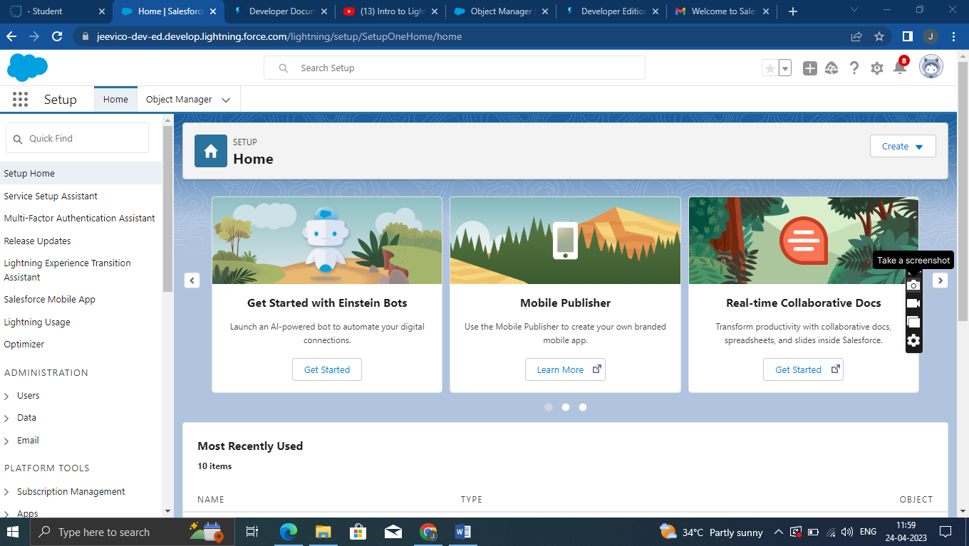

Salesforce Login

<https://login.salesforce.com/>

**Milestone:2**

**Object**

Salesforce objects are database tables that permit you to store data that is specific to an organization.  
  
Salesforce objects are of two types: Standard Objects: Standard objects are the kind of objects that are provided by salesforce.com such as users, contracts, reports, dashboards, etc.

**Custom objects:**

1.Semester

2.Candidate

3.Course Details

4.Lecturer Details

5.Internal results

**Activity:1**

**Create An Object**

Creation of Objects for Candidate Internal Result Card, For this Candidate Internal Result Card we need to create 5 objects i.e Semester, Candidate, Course Details, Lecturer Details, Internal Results.

The below steps will assist you in creating those objects.

1. Click on the gear icon and then select Setup.

2. Click on the object manager tab just beside the home tab.

3. After the above steps, have a look on the extreme right you will find a Create

Dropdown click on that and select Custom Object.

On the Custom Object Definition page, create the object as follows:

* Label: Semester
* Plural Label: Semesters
* Record Name: Semester Name
* Check the Allow Reports checkbox
* Check the Allow Search checkbox
* Click Save.  
    
   Now create a custom tab. Click the Home tab, enter Tabs in Quick Find and select
* Tabs.
* Under Custom Object Tabs, click New.
* For Object, select Semester.
* For Tab Style, select any icon.
* Leave all defaults as is. Click Next, Next, and Save.  
    
  To Navigate to Setup page:
* Click on gear icon then click setup.  
    
  To create an object:
* From the setup page then Click on Object Manager then Click on Create then Click on Custom
* Object.
* On Custom object defining page:
* Enter the label name, plural label name, click on Allow reports, Allow search then Save.
* 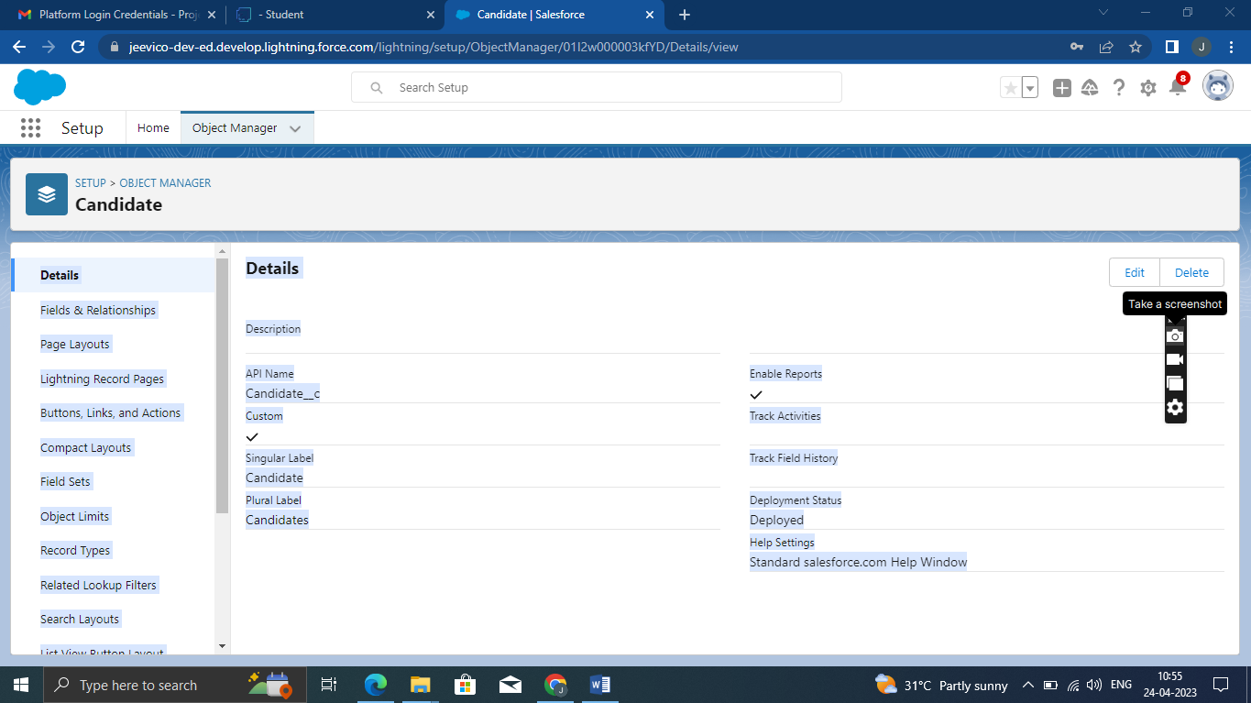

**Activity:2**

**Create Candidate, Course Details, Lecturer Details, Internal Results Objects.**

Follow Similar steps to create Candidate, Course Details, Lecturer Details, Internal results Objects.

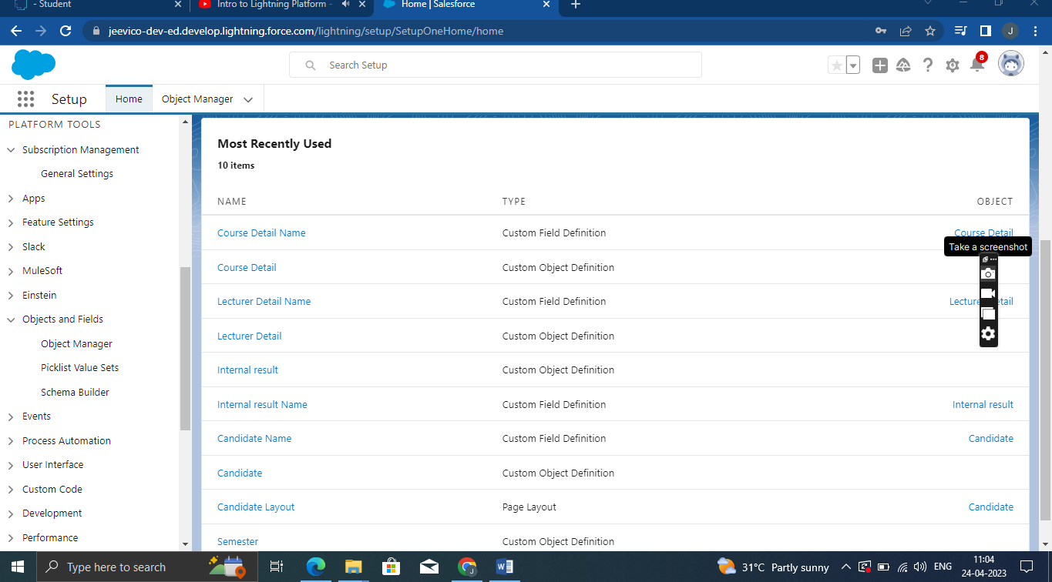

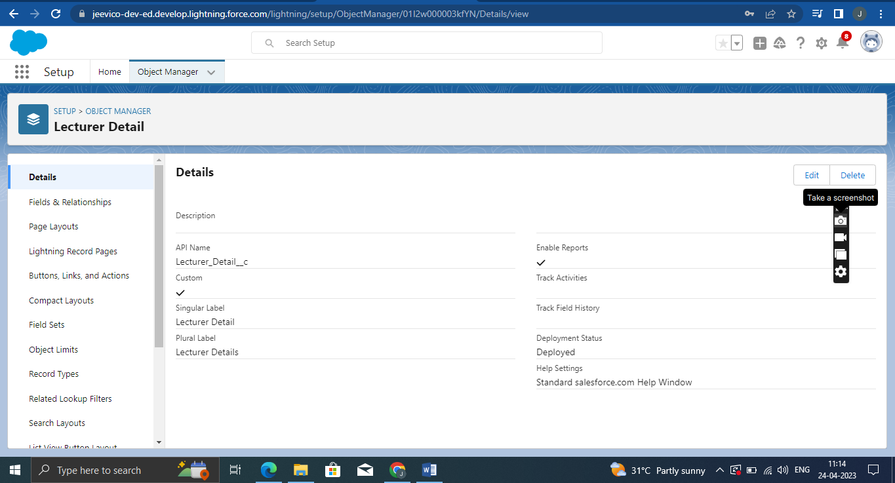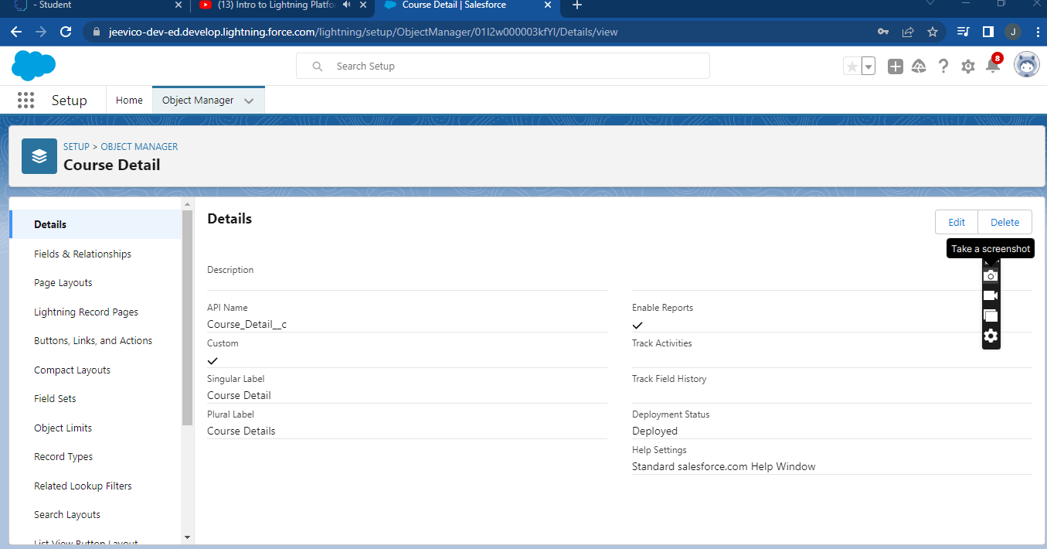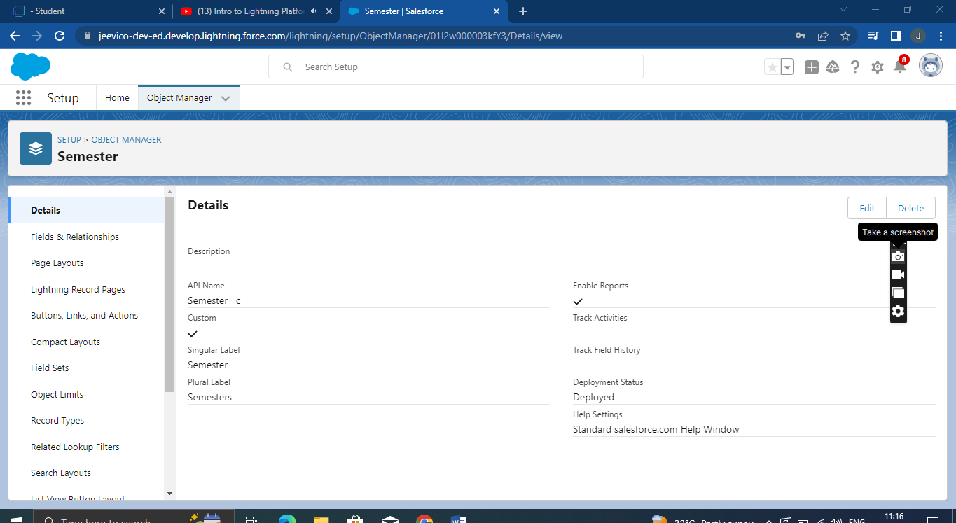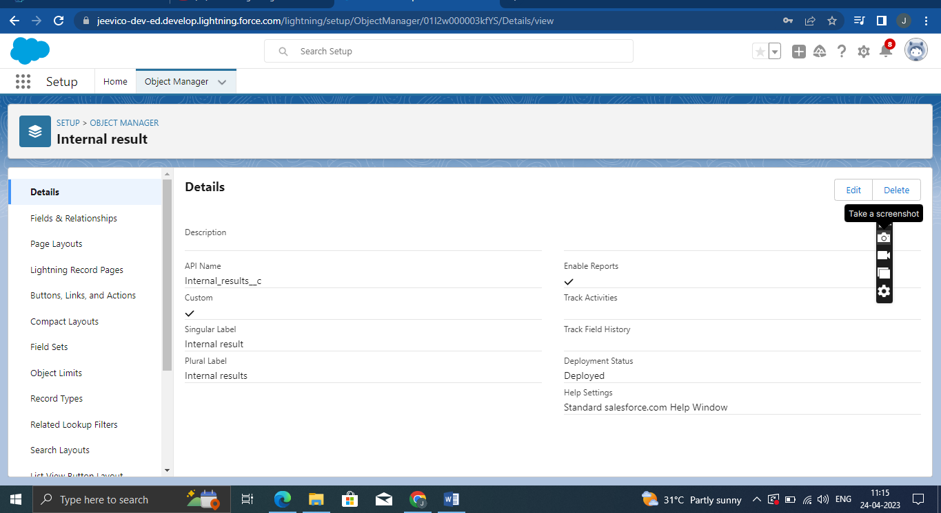

**Milestone:3**

**Fields And Relationship**

An object relationship in Salesforce is a two-way association between two objects.

Relationships are created by creating custom relationship fields on an object. This is done so that when users view records, they can also see and access related data.

**Activity:1**

**Creation Of Fields**

Creation of fields:

1. Click the gear icon and select Setup. This launches Setup in a new tab.

2. Click the Object Manager tab next to Home.

3.  Select Semester.

4. Select Fields & Relationships from the left navigation, and click New

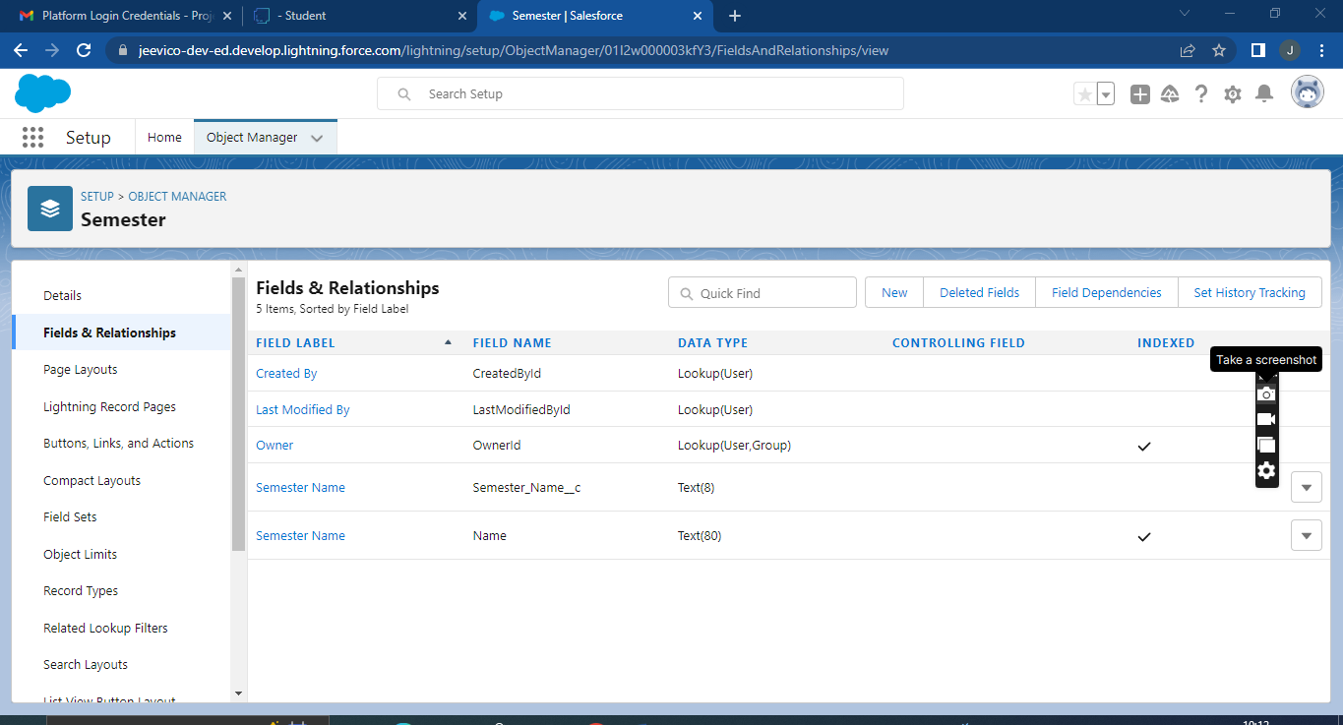

Now ready to make a custom field. Let's do this!

1. Select the Text as the Data Type, then click Next.

2. For Field Label, Enter Semester Name.

3. Click Next, Next, then Save  
  
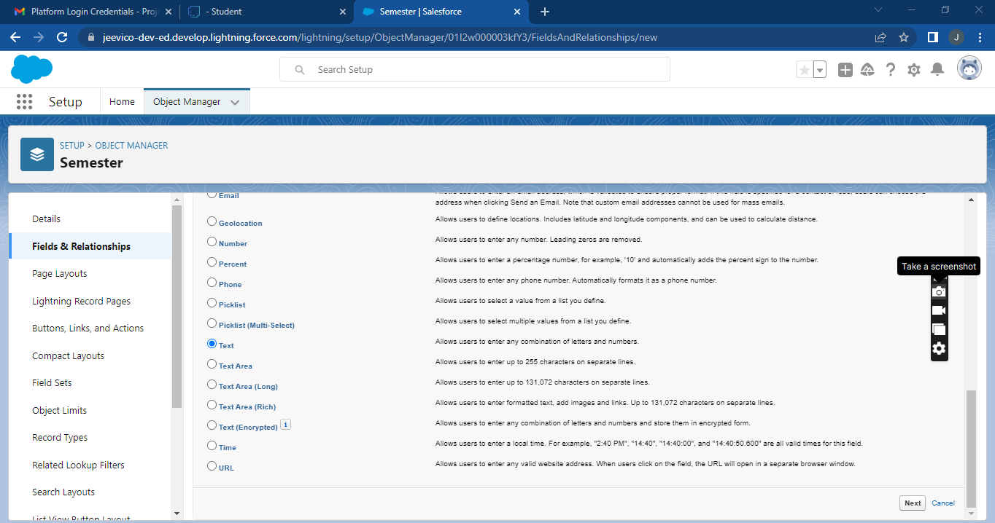

To create fields in an object:  
  
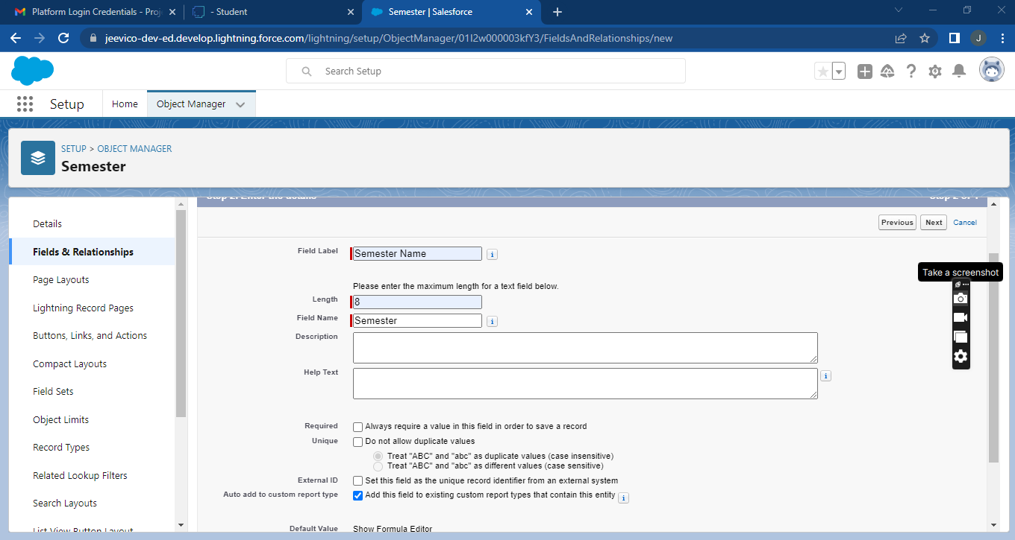

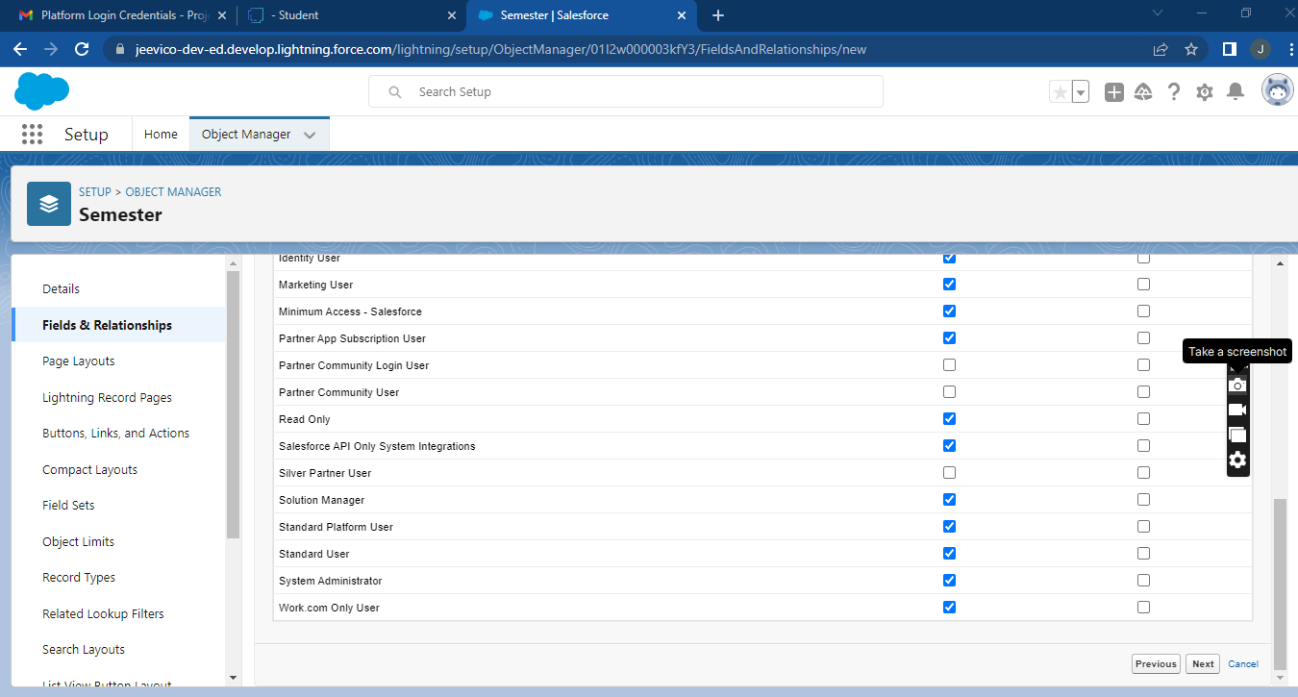

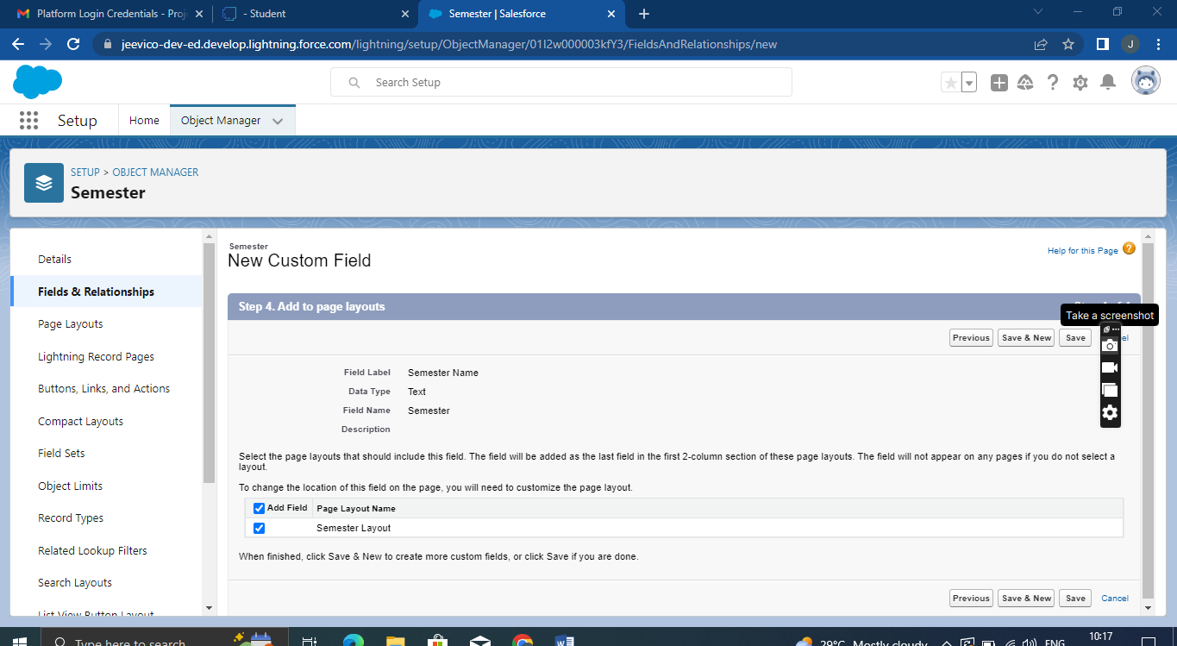

Go to setup then click on Object Manager then type object name in search bar then click on the

object.

Now click on “Fields & Relationships” then New

Fill the field label name then Next then Next then Save.

1. Click the gear icon and select Setup. This launches Setup in a new tab.

2. Click the Object Manager tab next to Home.

? Select Semester.

3. Select Fields & Relationships from the left navigation, and click New

Now ready to make a custom field. Let's do this!

1. Select the Text as the Data Type, then click Next.

2. For Field Label, Enter Semester Name.

3. Click Next, Next, then Save

To create fields in an object:

Go to setup then click on Object Manager then type object name in search bar then click on the

object.

Now click on “Fields & Relationships” then New

Fill the field label name then Next then Next then Save.

**Activity:2**

**Create Following Fields According To The Objects**

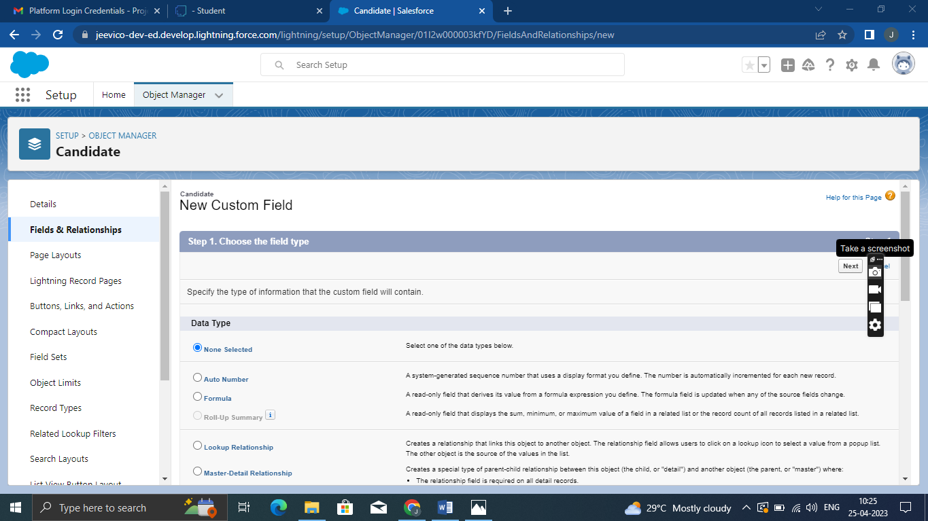

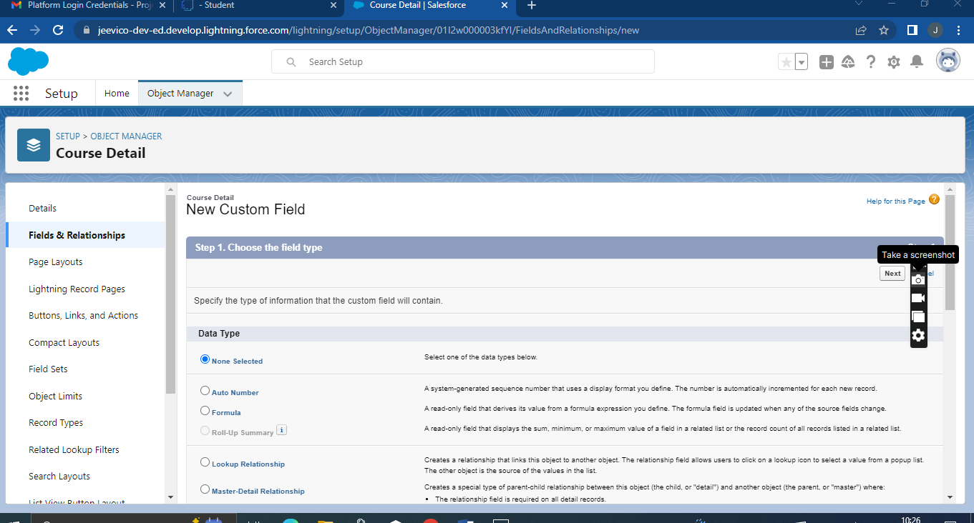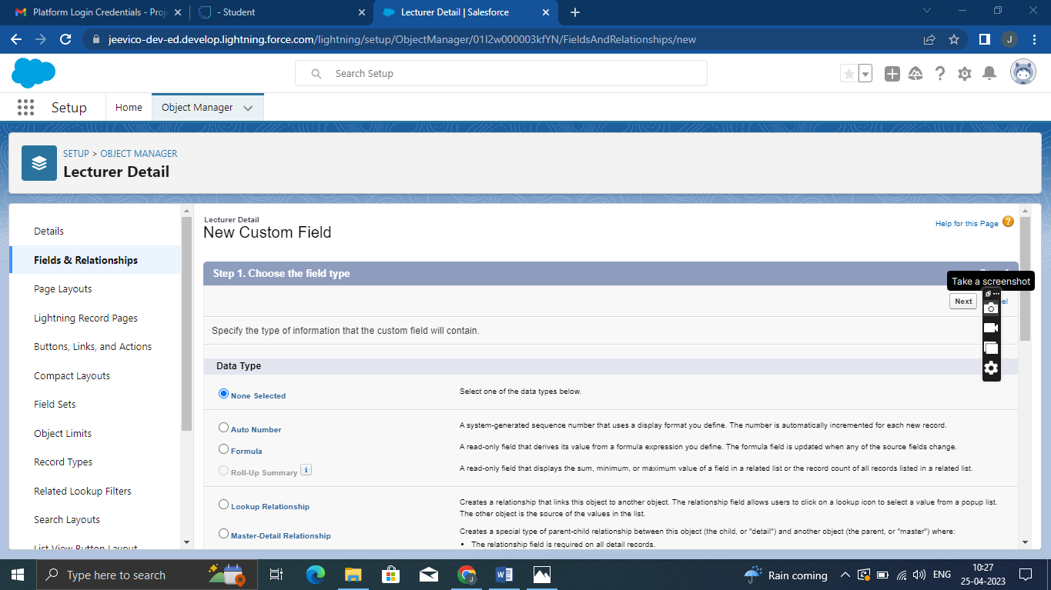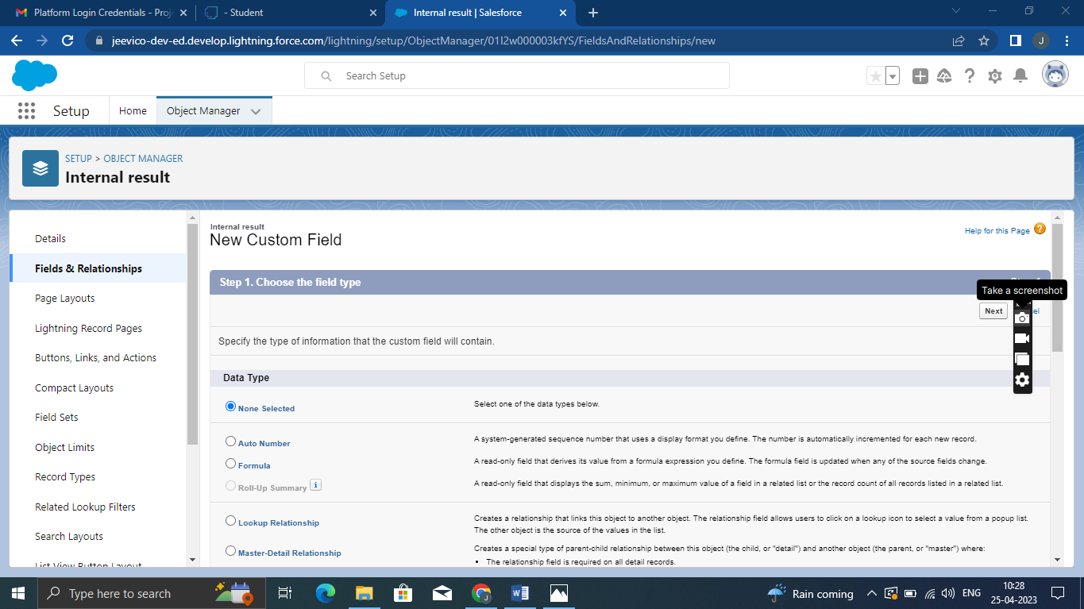

**Milestone:4**

**Lightning App**

Apps in Salesforce are a group of tabs that help the application function by working together as a unit. It has a name, a logo, and a particular set of tabs. The simplest app usually has just two tabs**.**

**Activity;1**

**Create The Candidate Internal Result Card App**

1. From Setup, enter App Manager in the Quick Find and select App Manager.

2. Click New Lightning App. Enter Candidate Internal Result Card as the App Name, then click Next

3. Under App Options, leave the default selections and click Next.

4. Under Utility Items, leave as is and click Next.

5. From Available Items, select Semester, Candidate, Course Details, Lecturer Details, Internal Results and move them to Selected Items. Click Next.

6. From Available Profiles, select System Administrator and move it to Selected Profiles. Click Save & Finish.

7. To verify your changes, click the App Launcher, type Candidate Internal Result Card and select the Candidate Internal Result Card app.

To create a lightning app page:

Go to setup page then search “app manager” in quick find then select “app manager” then click on New lightning App.

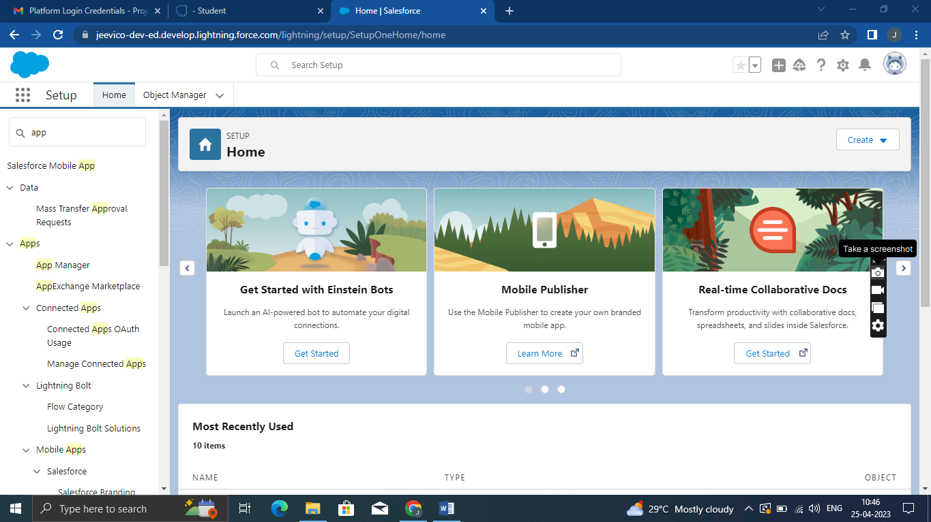

Fill the app name in app details and branding then  Next then (App option page) keep it as default then Next then (Utility Items) keep it as default then Next then (Add Navigation Items) then Next then (Add User Profile) Add System Administrator then Next.

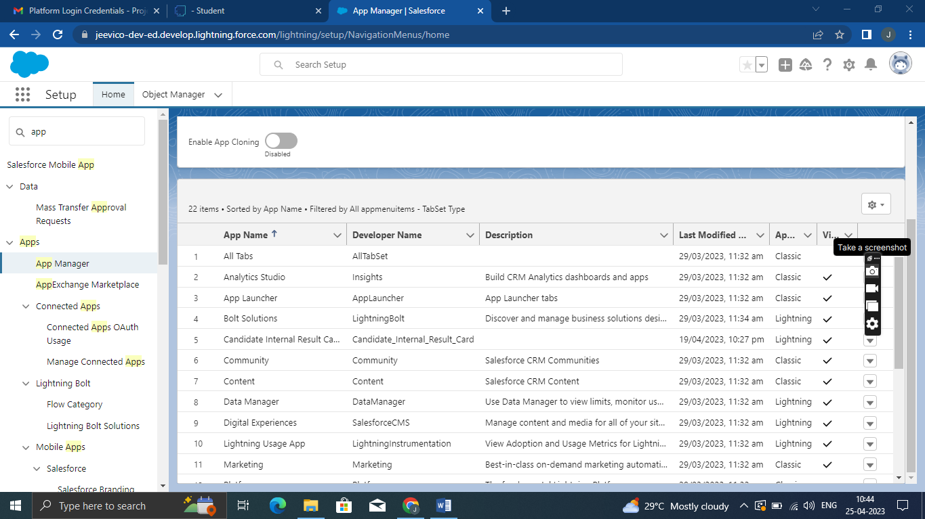

To Add Navigation Items:

Select the items from the search bar and move it using the arrow button then Next.

To Add User Profiles:

Search profiles in search bar then click on the arrow button then save & finish.

**Milestone :5**

**Users**

A user is anyone who logs in to Salesforce. Users are employees at your company, such as sales reps, managers, and IT specialists, who need access to the company's records. Every user in Salesforce has a user account.

**Activity:1**

**Creating A Users**

1. From Setup, in the Quick Find box, enter Users, and then select Users.

2. Click New User.

3. Enter the user’s name John Martin and (Your) email address and a unique username in the form of an email address. By default, the username is the same as the email address.

4. Select a Role(none)

5. Select a User Licence As salesforce.

6. Select a profile as Salesforce User.

7. Check Generate new password and notify the user immediately to have the user’s login name and a temporary password emailed to your email.

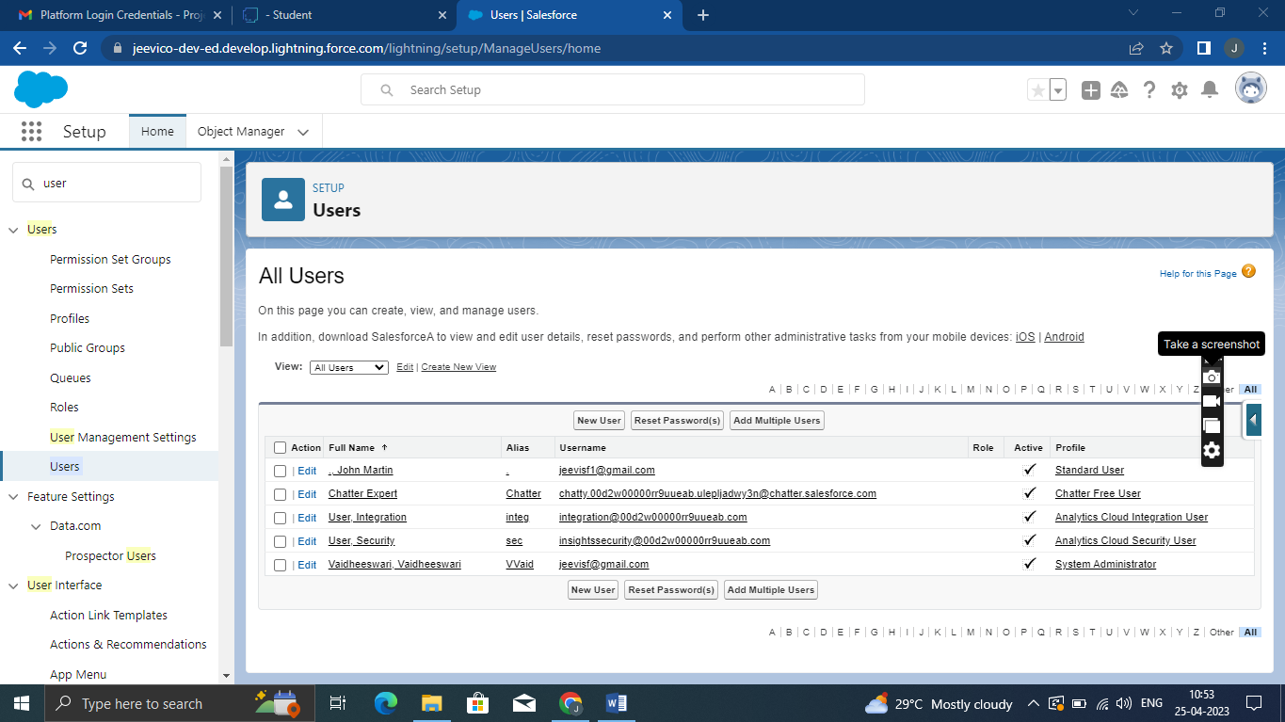

**Milestone:6**

**Reports**

A report is a list of records that meet the criteria you define. It's displayed in Salesforce in rows and columns, and can be filtered, grouped, or displayed in a graphical chart. Every report is stored in a folder. Folders can be public, hidden, or shared, and can be set to read-only or read/write.

**Activity;1**

**Reports And Dashboards**

1. From the Reports tab, click New Report.

2. Select the report type as Candidate with candidate Marks for the report, and click Create.

3. Customize your report, then save or run it.

To create a report:

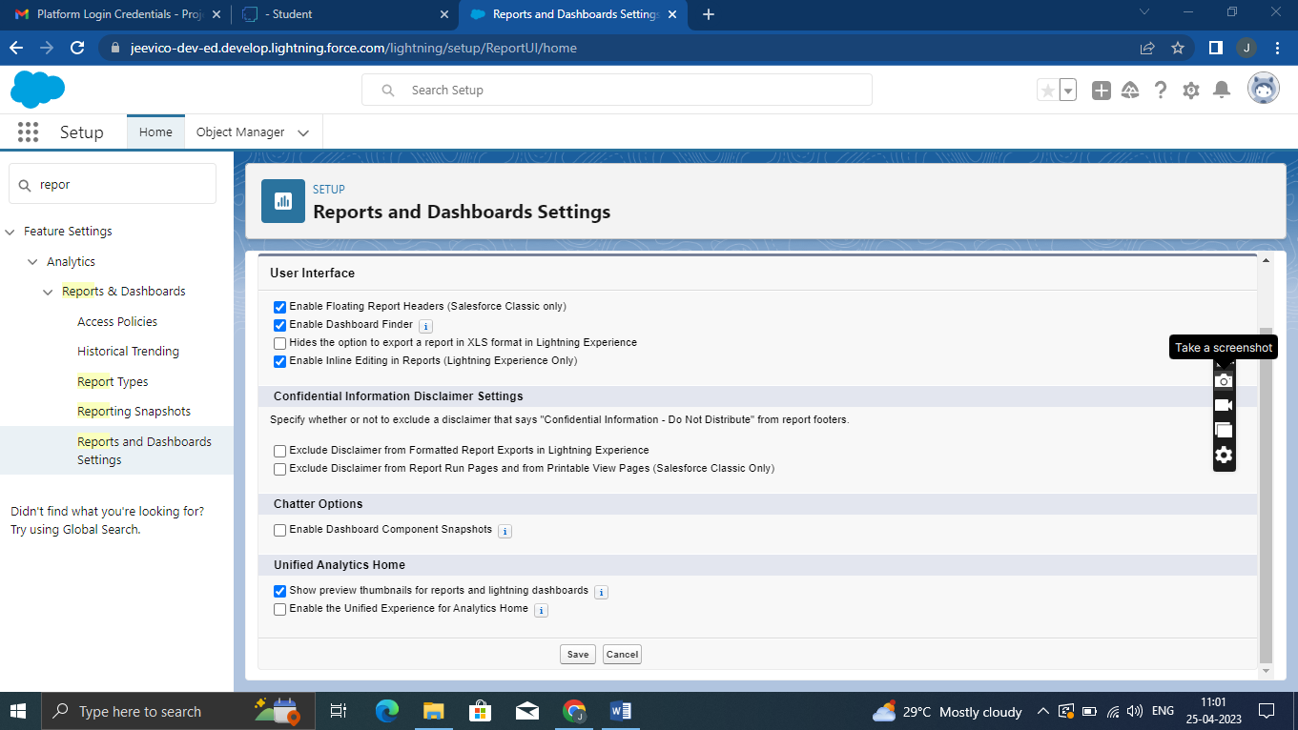

a. Go to the app and click on the reports tab  
  
b. Click New Report

c. Select report type from category or from report type panel or from search panel then click on

start report.

d. Customize your report, then save or run it.

**Milestone:7**

**Dashboards**

Dashboards let you curate data from reports using charts, tables, and metrics.

If your colleagues need more information, then they're able to view your dashboard's data-supplying reports. Dashboard filters make it easy for users to apply different data perspectives to a single dashboard**.**

**Activity:1**

**Create A Dashboard**

1. Click the Dashboards tab.

2. Click New Dashboard.

3. Name your dashboard Candidate Board . Leave all other fields as is and click Create.

4. Click + Component.

5. For Report, select Candidate Marks by Stage. Click Select. ...

6. For Display As, select Vertical Bar Chart and click Add.

7. Click Save.

8. Click Done

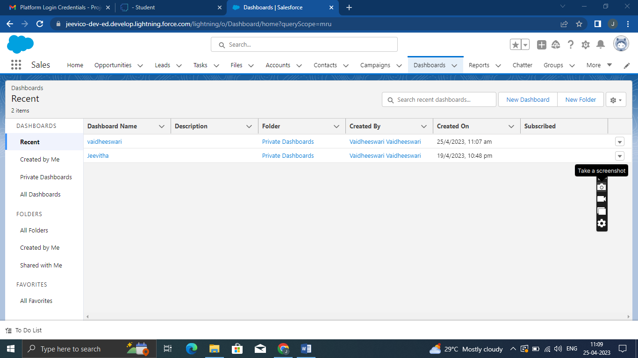

**4 Trailhead Profile Public URL**

**Team Lead-**[**https://trailblazer.me/id/vvaidheeswari**](https://trailblazer.me/id/vvaidheeswari)

**Team Member 1 –** [**http://trailblazer.me/id/cvisuvanathan**](http://trailblazer.me/id/cvisuvanathan)

**Team Member 2-** [**https://trailblazer.me/id/bbala229**](https://trailblazer.me/id/bbala229)

**Team Member 3 -** [**https://trailblazer.me/id/rramamurthi**](https://trailblazer.me/id/rramamurthi)

**5 ADVANTAGES AND DISADVANTGE**

**1*Advantages**

 ["***advantage in***" crm implementation in salesforce](https://www.google.com/search?rlz=1C1CHBF_enIN1018IN1018&biw=1034&bih=620&q=%22advantage+in%22+crm+implementation+in+salesforce&spell=1&sa=X&ved=2ahUKEwj419-C_tD-AhVrwzgGHTmzAaoQBSgAegQIBxAB)

No results containing all your search terms were found.

Your search - **"advantage" implementation in** - did not match any documents.

Suggestions:

* Make sure that all words are spelled correctly.
* Try different keywords.
* Try more general keywords.
* Try fewer keywords.

**Disadvantage**

the disadvantages of using Salesforce?

**Salesforce cons**

* Expensive.
* You have to pay for add-ons to get the most out of the software.
* Configuration and setup is complex and time-consuming.
* Cluttered interface makes navigation and simple tasks unnecessarily complex.
* The learning curve never seems to end.
* Customer support has a poor reputation.

**6 Application**

Administrator should be able to create all base data including Semester, Candidate, Course and Lecturer, Lecturer should have the ability to create Internal Results, Dean, who is one of the Lecturer, should be the only one with ability to update Internal Results, Re-evaluation Can be initialized by Candidate for all Internal Results. Now only dean can update the marks after re-evaluation.

**7 Conclusion**

Conclusion Customer Relationship management is a business strategy that enables a business organization tomaximize revenue, customer satisfaction, profitability through strategic mobilization, organization, and management of customer’s interests and desires. BWM has traversed numerous business challenges that made it establish a CRM that will foster customer relationship as a baseline for market strengthening and diversification. BMW has diversified its market in various global markets through the initiation of the CRM systems. The system has significantly contributed to the company’s financial, operational, managerial and development initiatives with a robust customer relationship that has fostered great sale of its produc.

**8 Future Scope**

“[The future of CRM] is about which companies will be able to pivot to meet the changing needs and trends — driven by customer expectations. Customers expect organizations to know a lot about them and expect to have conversations.

The 4 most important CRM goals and objectives are:

1. Increase customer retention

Shorten the sales cycle

1. Sell more
2. Decrease your customer acquisition cost

The goals of CRM are generally to create a better customer experience — and because of that customer experience, to get more sales. That’s why it’s called CRM (Customer Relationship Management) software, and if you focus on your relationships, you’ll be on your way to your CRM goals.